ITEM DESCRIPTION PRICE

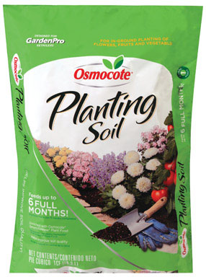
#1 Osmocote Planting Soil $7.99
· 1 Cubic Foot Coverage
· Feeds up to 6 months
· For in-ground plantings of flowers,
fruits and vegetables
· Helps improve soil quality
· Enriched with Osmocote smart-
release plant food
· Contains rich organic materials
including sphagnum peat moss
7269467
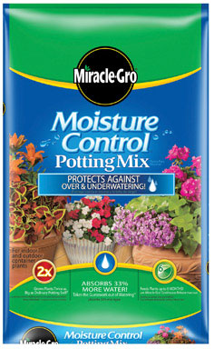
#2 Miracle-Gro Moisture Control $9.99
Potting Mix
· 1 Cubic Foot Coverage
· Feeds for up to 6 months
· Holds 33% more water
· Contains Aqua Coir, a unique blend
of coconut fibers, sphagnum peat moss
and a wetting agent
· This combination absorbs excess moisture
and releases it as the plant needs it
7123813
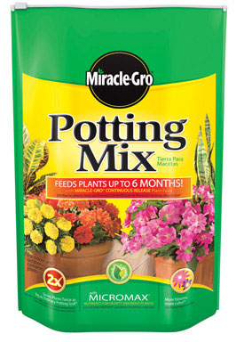
#3 Miracle-Gro Potting Mix $6.49
· 16 Qt. Coverage
· Enriched with Miracle-Gro plant food
to get plants off to a great start
· Formula includes continuous release
plant food – feeds for up to 3 months
· Indoor/Outdoor containers

7087737
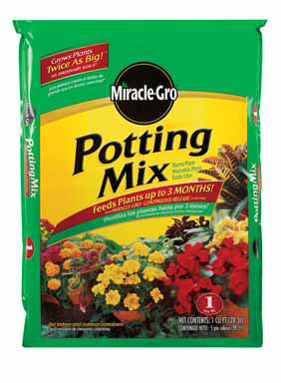

#4 Miracle-Gro Potting Mix $8.99
· 1 Cubic Foot Coverage
· Enriched with Miracle-Gro plant food
to get plants off to a great start
· Formula includes continuous release
plant food – feeds for up to 3 months
· Indoor/Outdoor containers

7104045
ITEM DESCRIPTION PRICE
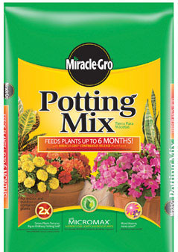

#5 Miracle-Gro Potting Mix $12.99
· 2 Cubic Feet Coverage
· Enriched with Miracle-Gro plant food
to get plants off to a great start
· Formula includes continuous release
plant food – feeds for up to 3 months
· Indoor/Outdoor containers

7104052
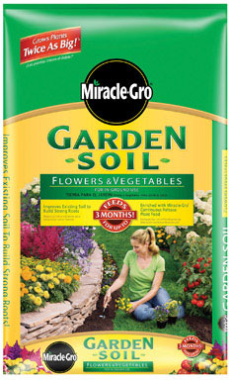
#7 Miracle-Gro Garden Soil $5.99
· 1 Cubic Foot Coverage
· Specially formulated for annuals and
perennials as well as all types of
vegetables
· Water absorbent formula helps keep
young plants from drying out
· Enriched with Miracle-Gro plant food
to get plants off to a great start
· Formula includes continuous release
plant food
7102692
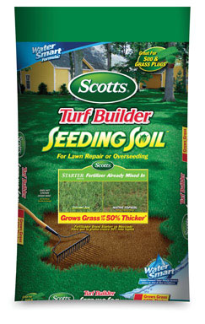

#8 Scotts TB Seeding Soil $5.99
· 1 Cubic Foot Coverage
· Ideal for planting new lawns, or
repairing bare spots
· Blend of organic materials, sphagnum
peat moss and a wetting agent
· Enriched with Scotts fertilizer for quicker,
stronger root development
· 33% more germination vs. topsoil

7106198
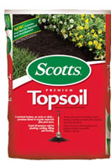
#10 Scotts Premium Topsoil $2.99
· 0.75 Cubic Foot Coverage
· Premium blend of organic materials
· Peat moss added

71151750
ITEM DESCRIPTION PRICE
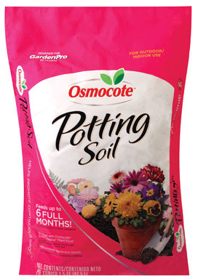
#11 Osmocote Potting Soil $12.99
· 1.5 Cubic Feet Coverage
· Feeds up to 6 months with
Osmocote smart-release plant food
· Indoor/Outdoor use
· Contains rich, organic material
· Sphagnum peat moss boasts water
retention and perlite improves drainage

7269459
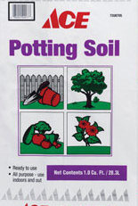
#13 Ace Potting Soil $3.99
· 1 Cubic Foot Coverage
· Ready to use
· All purpose for indoor and outdoor use
· Contains forest wood products, compost
bark, perlite and sand

7208705
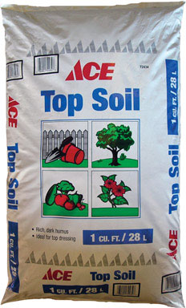
#14 Ace Topsoil $2.49
· 1 Cubic Foot Coverage
· Rich, dark topsoil
· Ideal for top dressing
· Contains forest wood products and
compost bark
· Can be used to build mounds in the
landscape

7204076

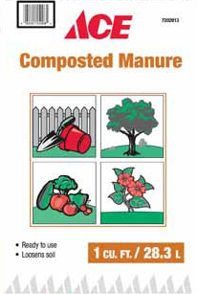
#16 Ace Composted Manure $2.99
· 1 Cubic Foot Coverage
· Natural organic year and garden
fertilizer
· Ready to use loosen soil

7202013
ITEM DESCRIPTION PRICE
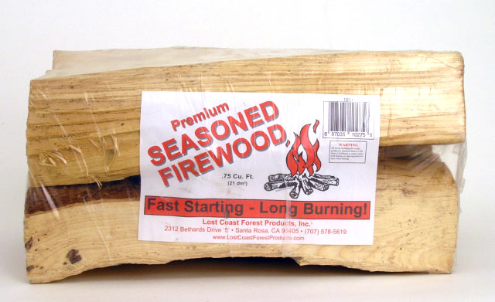
#17 Premium Firewood $5.49
· 0.75 Cubic Feet
· Starts fast
· Burns long

012272
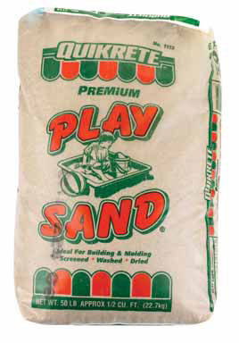
#18 Play Sand $4.99
· 50 lbs.
· Specially graded sand that has
been washed, dried, and screened
· For children’s sand boxes

58173
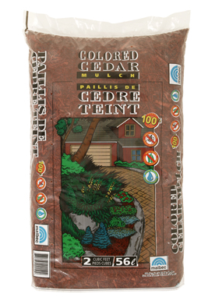
#19 Red Mulch $4.99
· 2 Cubic Feet Coverage
· Easy to spread
· Natural forest products and colorant
· Prevents moisture loss

7100449
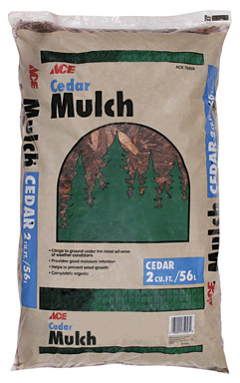

#22 Cedar Mulch $4.99
· 2 Cubic Feet Coverage
· Good color retention
· Insect resistant
· Retards weed growth

75958

ITEM DESCRIPTION PRICE

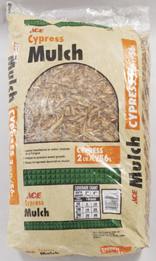
#23 Cypress Mulch $3.99
· 2 Cubic Feet Coverage
· Resists water insects and fungus
· Retards weed growth

72242
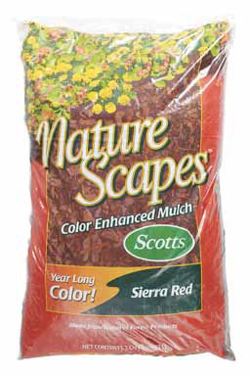

#28 Naturescape Red Mulch $4.99
· 2 Cubic Feet Coverage
· Helps condition the soil for better
plants
· Made from natural forest products

7269483
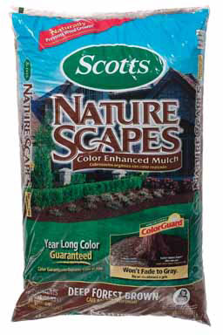
#29 Naturescape Brown Mulch $4.99
· 2 Cubic Feet Coverage
· Provides organic matter to the soil
to help plants
· Adds a finishing touch to gardens
and landscapes
· Safe and beneficial for plants

7269491

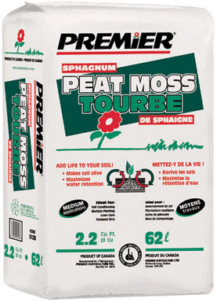
#30 Sphagnum Peat Moss $9.99
· 2.2 Cubic Feet Coverage
· Used as a based material for planting,
transplanting live nursery stock, flowers,
trees, any horticulture application
· Use indoor or outdoor
· Aerates soils
· Adds organic content to sandy soils
· Improves water drainage and nutrient/
Water retention
· Saves water
70585
ITEM DESCRIPTION PRICE
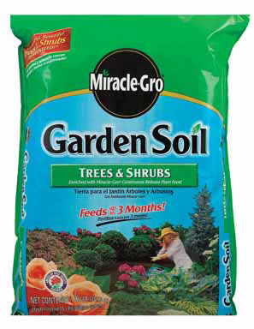

#32 Miracle-Gro Garden Soil $5.99
· 1 Cubic Foot Coverage
· Feeds up to 3 months
· Fortified with all of the essential
nutrients to promote vigous blooms,
foliage and root growth
· Ideal for all types of deciduous, evergreen
and flowering trees and shrubs
· Enriched with Miracle-Gro plant food
to get plants off to a great start
7102700
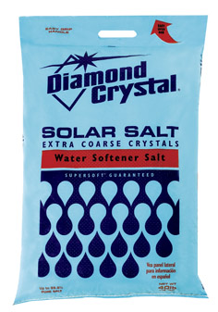
#46 Softener Salt $4.49
· Extra coarse crystals
· 40 lbs.
· Cleaner and more efficient than rock salt
· No channeling, brigging or mushing
· Works in all water softeners

X0100020

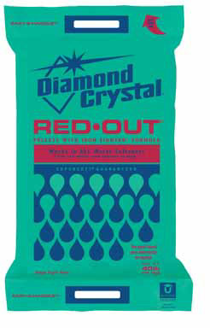
#47 Softener Salt $6.99
· Red-Out pellets
· 40 lbs.
· Specially formulated for use in areas
W with high iron content
· Works in all water softeners

7036718
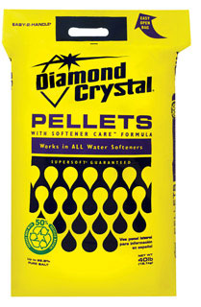
#48 Softener Salt $4.99
· Pellets
· 40 lbs.
· Works in all water softeners

X44822

ITEM DESCRIPTION PRICE

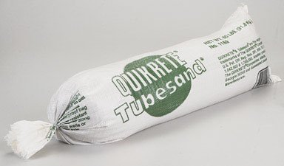
#52 Tube Sand $5.99
· 60 lbs.
· Tube shaped bag fits along
side rear axle, above wheel wells
or in bed of pick-up trucks
· Use for traction and vehicle weight
for winter driving conditions

